**Lab1 – GitHub - Install Eclipse to Run Java***Scoring: 20 pts***Please complete Tutorials 1 and 2 before starting the lab assignment.  
This assignment is an individual submission.**

**Activity Results: This lab teaches you the following topics:**

✅ **To upload your Intro to SE-LAB-Exercises to the GitHub repository**

✅ **How to Download and Install Eclipse to Run Java**

1. What are the steps involved in creating a new repository on GitHub, and how can you add files to it using the command line?

2.Create a repository and call it **CS-380-Intro-to-SE-SP-2023**.

3.How can you reverse a given number in Java, and what would be the code implementation for it?

Ex. Given Number  
12345  
Reverse Number  
54321

**How do I submit my assignment?**

1. Answer each question in a word document. After that, capture a screenshot of your terminal with your code and output and paste it into a Word document, then save it as a PDF.

2. Make a folder in your host operating system called OS380 lab-assignments and save your  
first lab in that folder.

3. Upload your pdf file to your repository "**CS-380-Intro-to-SE-SP-2023**" from Tutorial 1 is in our repository for this class.

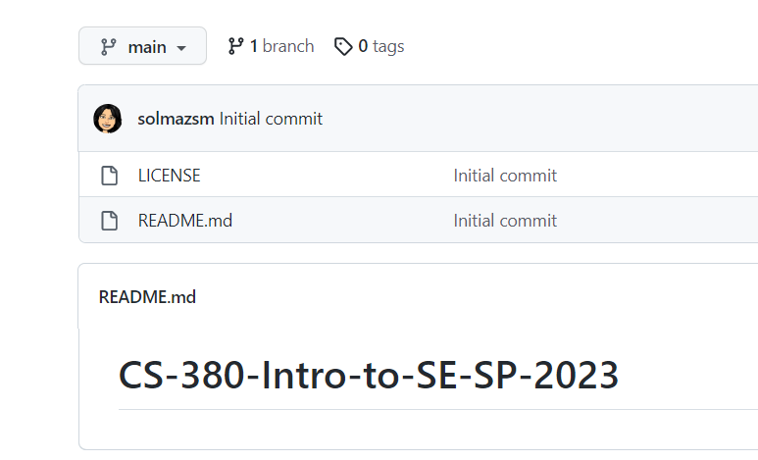

4. Upload a URL repository to the canvas.